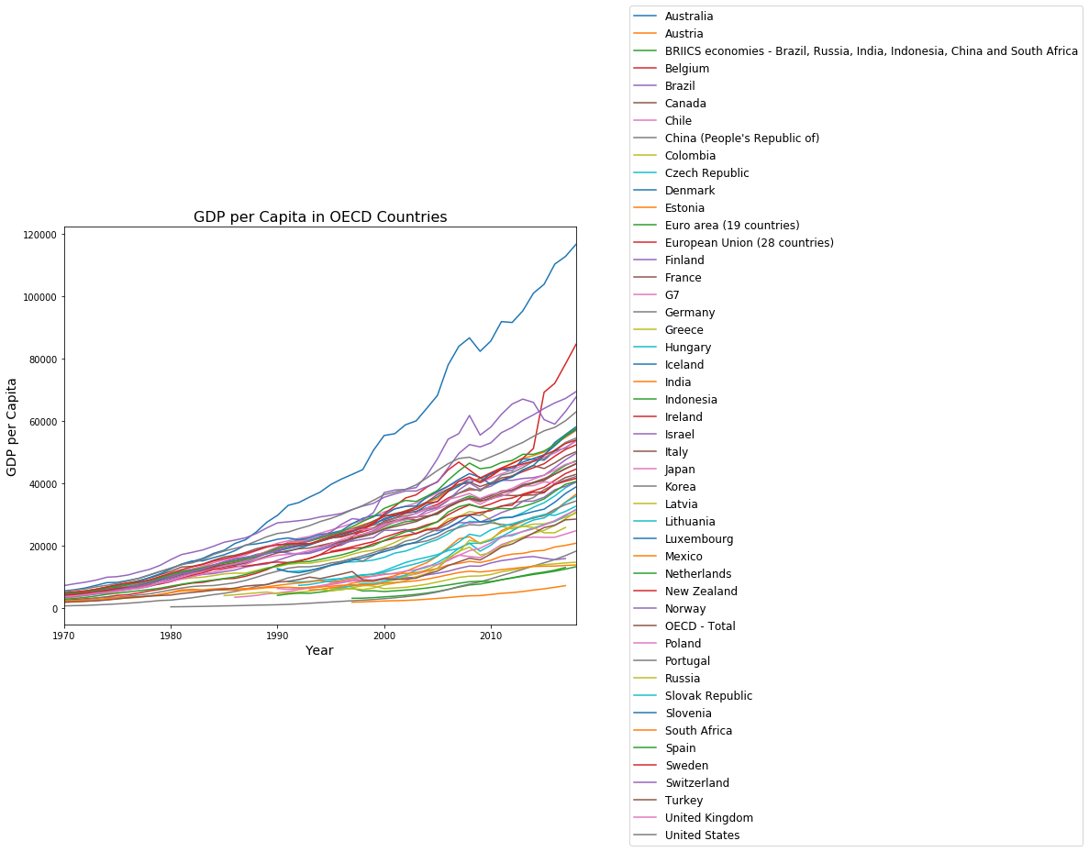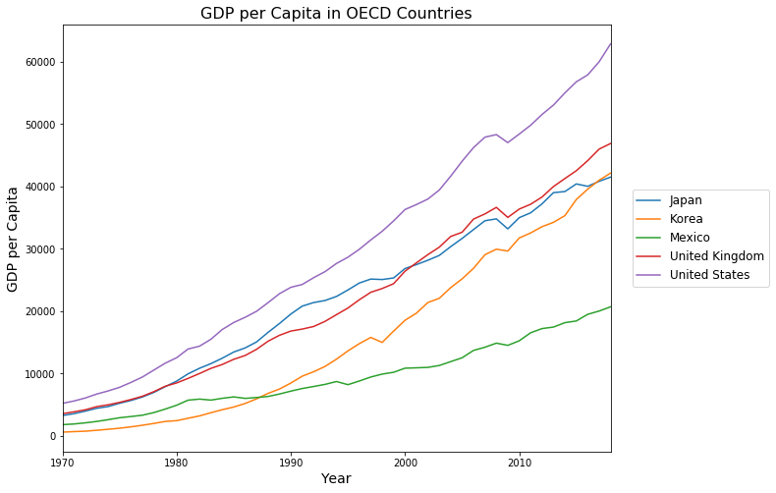

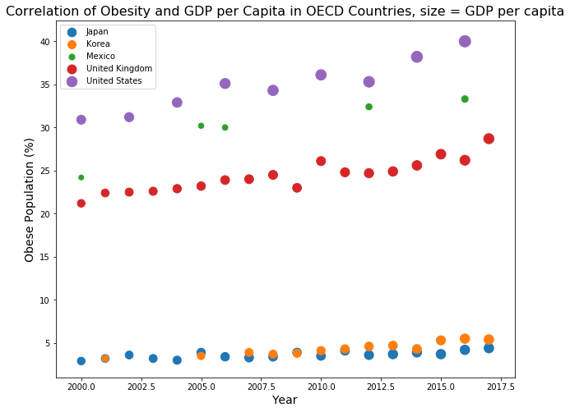

Compared to other high income countries, Japan’s obesity rate is very low. Several factors are thought to influence this. The average person in Japan consumes 200 calories less per day than the average person in the US. Food prices and the cost of automobiles are higher. On the average, each Japanese above 15 years of age walks almost 4 miles per day.

<https://www.nationmaster.com/country-info/stats/Health/Obesity>

A recent study by Neuman and colleagues [[8](https://journals.plos.org/plosone/article?id=10.1371/journal.pone.0178928#pone.0178928.ref008)] investigated *inter alia* the relationship between GDP per capita and BMI in 38 low and middle income countries. Findings of the study suggested, on average, BMI increased with increasing national wealth. However, there was a cross level interaction between GDP per capita and individual wealth and BMI. Individuals from the wealthiest quintiles in the poorest countries tended to have an appreciably higher BMI than those in the poorer quintiles, whereas the individuals from the wealthiest quintiles in the very wealthiest of the middle-income countries tended to have a BMI more consistent with the other quintiles of wealth. That is, the BMI of the poorer and the wealthier converged in the wealthiest middle-income countries.

Masood, M., & Reidpath, D. D. (2017). Effect of national wealth on BMI: An analysis of 206,266 individuals in 70 low-, middle- and high-income countries. *PloS one*, *12*(6), e0178928. <https://doi.org/10.1371/journal.pone.0178928>

Socio-economic status and body mass index in low-income Mexican adults

doi: [10.1016/j.socscimed.2007.02.002](https://dx.doi.org/10.1016%2Fj.socscimed.2007.02.002)

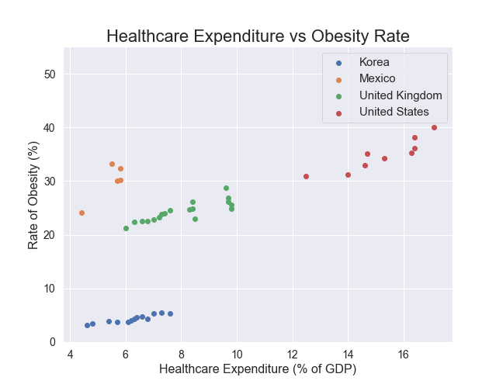

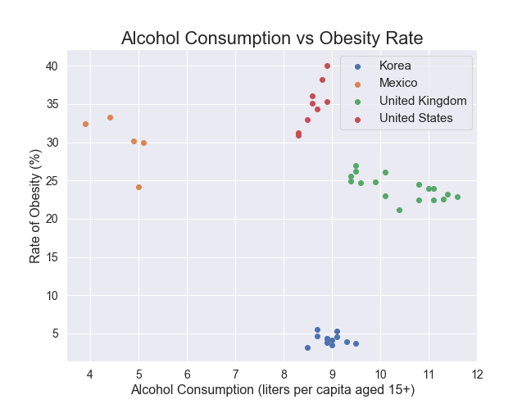

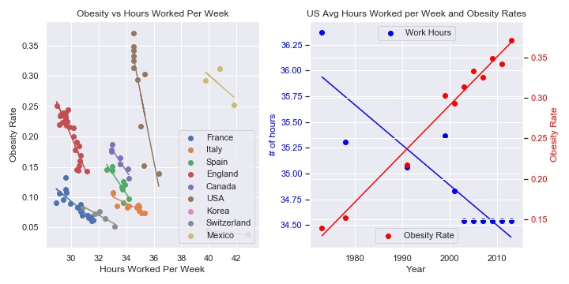

OECD (2020), Hours worked (indicator). doi: 10.1787/47be1c78-en (Accessed on 08 April 2020)

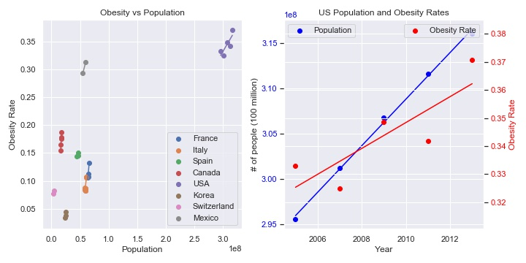

<https://stats.oecd.org/Index.aspx?DataSetCode=EDU_DEM>

Sugar Sweetened Beverage consumption

